As of January 2026, the graduation application process follows a staged workflow within the Advising Hub. When a student submits an application, the assigned advisor is notified to begin the review.

Advisor Approval Steps

Receive Notification:
You will receive an automated email as soon as one of your advisees submits a graduation application through the Success Hub.

Access the Advising Hub:
Log into the Student Workflow Portal (Advising Hub) at https://apply.cccc.edu/portal/advisor?tab=Home.
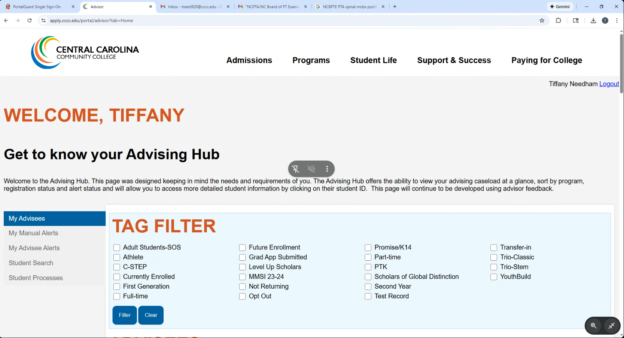

Locate the Application:
Navigate to your "Student Processes/Graduation Request" box to view pending applications.
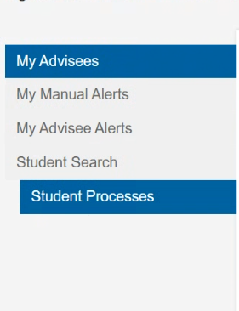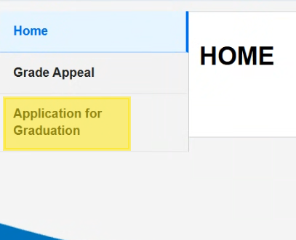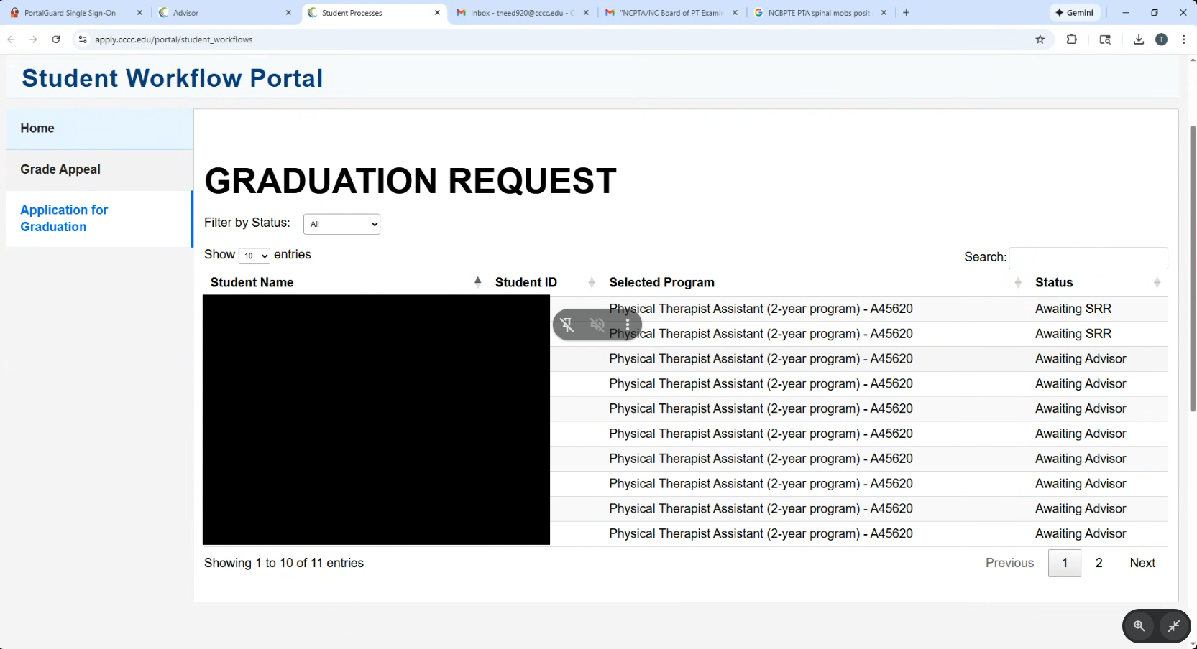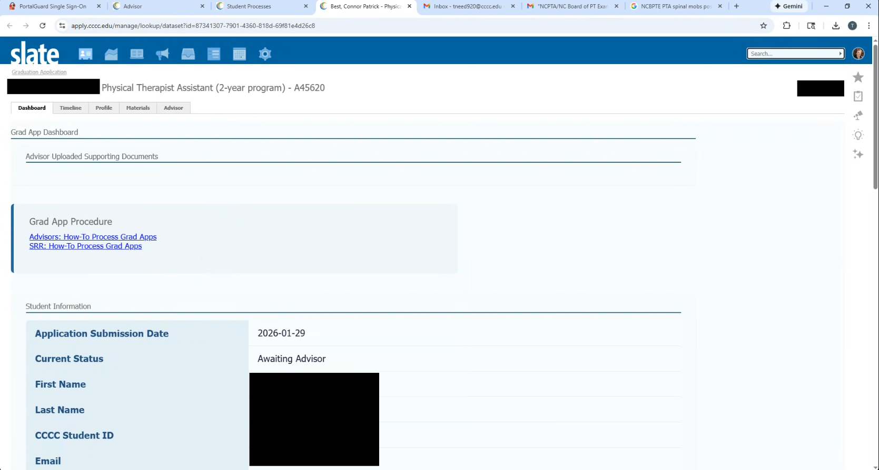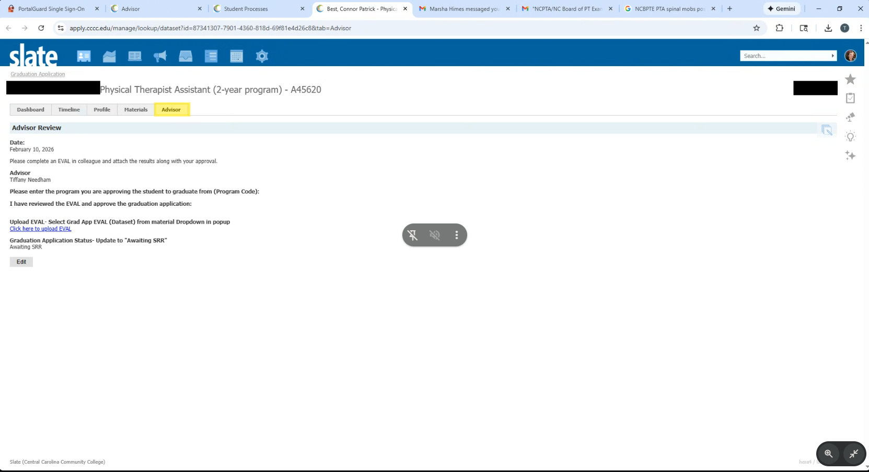

Perform EVAL:
Access Colleague and use the EVAL mnemonic to perform a formal degree audit.
  - GPA Check: Verify the student has at least a 2.0 Program GPA and a 2.0 Cumulative GPA.
  - Stackable Credentials: If the student is earning multiple credentials (e.g., a degree and a certificate), you must review and approve a separate application for each award.
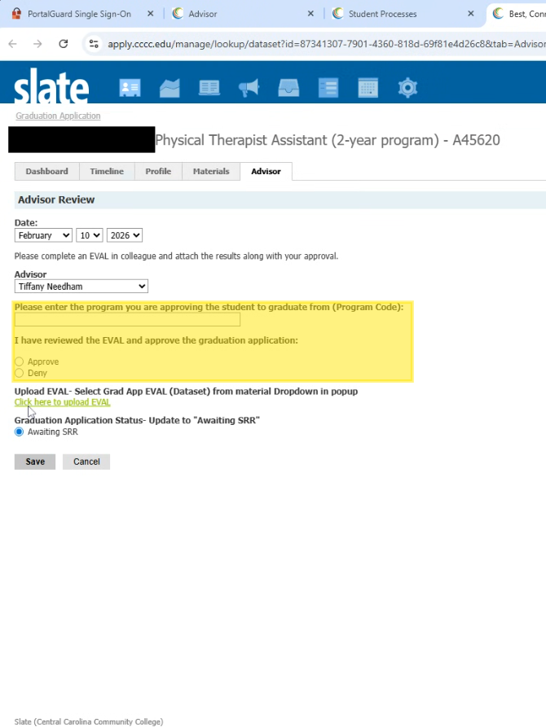

Upload Audit:
You are required to upload the completed EVAL document directly into the Advising Hub as part of the approval process.
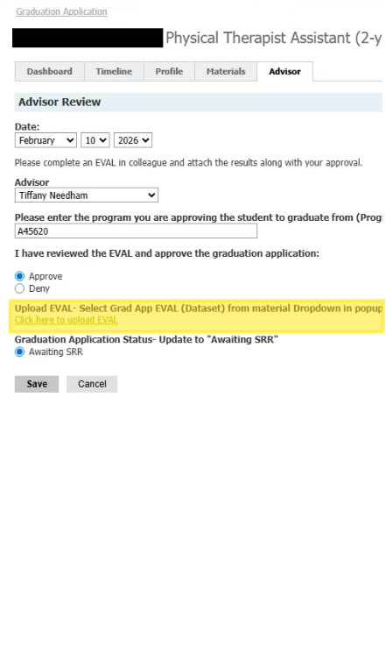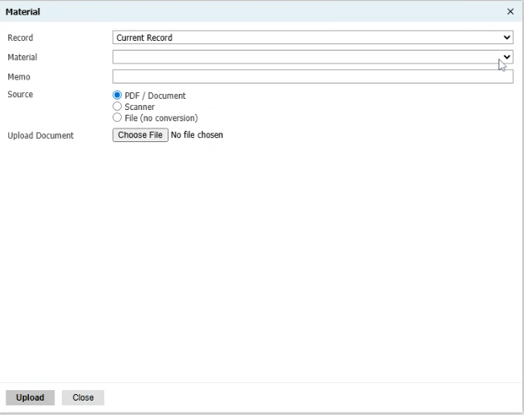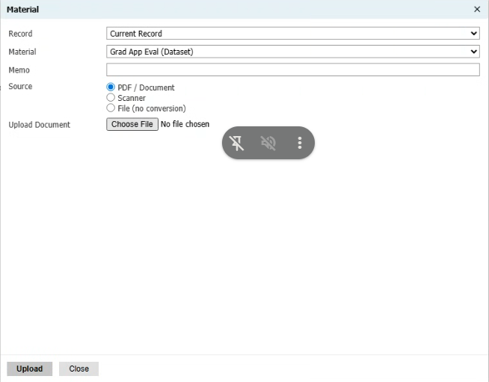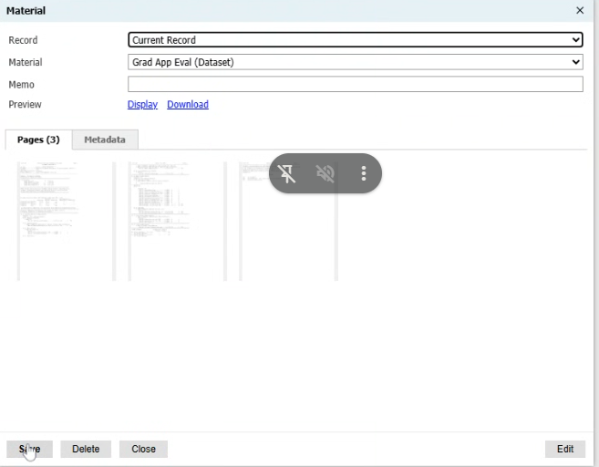

Submit Approval:
Complete the online approval form in the portal. Once you submit, the application will move to the Student Records and Registrar’s Office for final technical auditing. You may need to refresh the Dashboard tab to see the updated status.
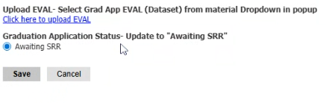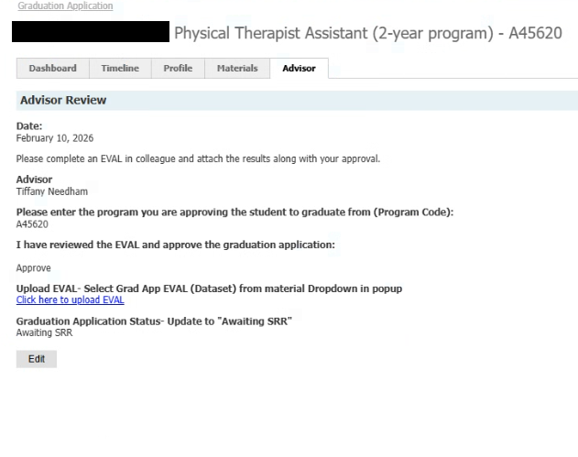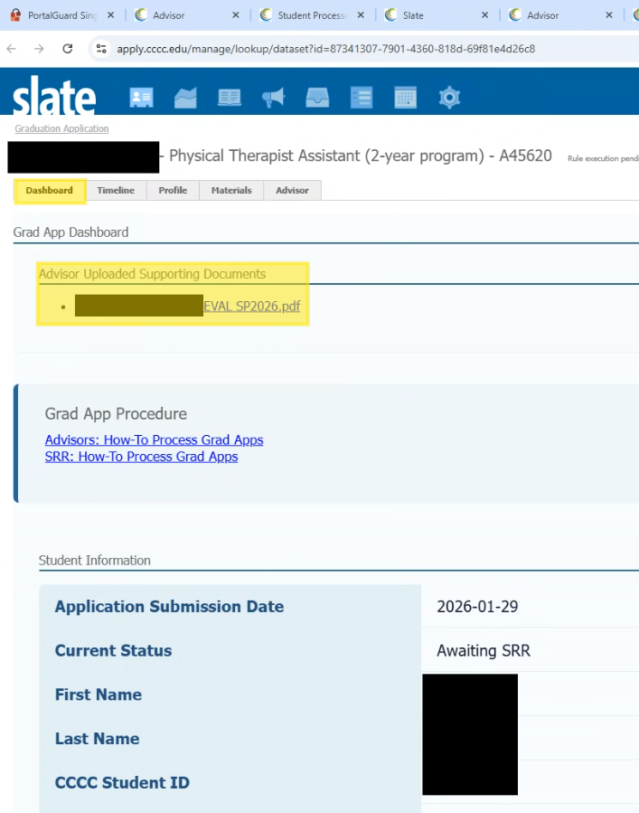

Internal Guidance for SRR Staff
- Technical Issues: If an advisor reports that they cannot see a specific student's application, it may be due to the student having multiple advisors assigned, or the lack of that advisor on their record. Direct the advisor to the link provided by Stormy Mascitelli to view all grad apps by status.
- Incomplete EVALs: If an EVAL shows an "I" grade for a required course, the advisor should not approve until the Requirements to Remove an Incomplete form is verified; otherwise, the grade reverts to an "F" by the midterm of the following semester.

